**Project 5200 – Iowa Liquor Sales Analysis : by Group 1**

**(Codes and Screenshots)**

**Connect to Oracle Cloud:**

ssh [apaul11@129.150.71.75](mailto:apaul11@129.150.71.75)

**[Note:** We also used alternatively ssh [tkhan9@129.150.71.75](mailto:tkhan9@129.150.71.75) in the later part since apaul11’s account ran out of storage space.**]**

**Download the data file from Amazon S3:**

wget -O iowa_Liquor_Sales.csv https://projectcis5200.s3-us-west-1.amazonaws.com/iowa_Liquor_Sales.csv 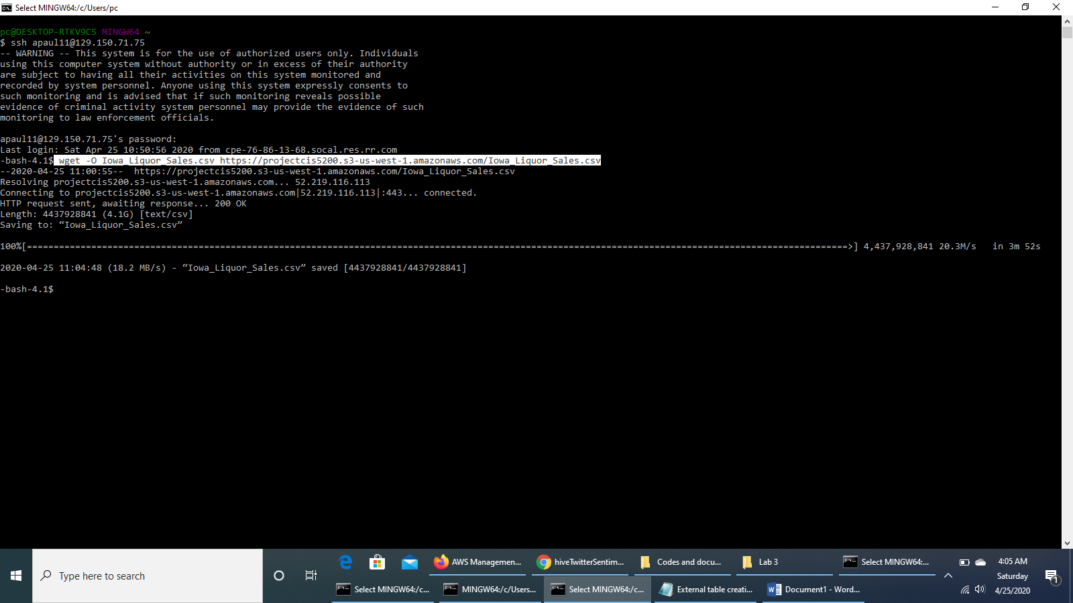

**Upload the Iowa_Liquor_Sales.csv file to *projectfolder* directory of HDFS**

hdfs dfs -mkdir projectfolder

hdfs dfs -ls

hdfs dfs -put Iowa_Liquor_Sales.csv projectfolder/

hdfs dfs -ls projectfolder/

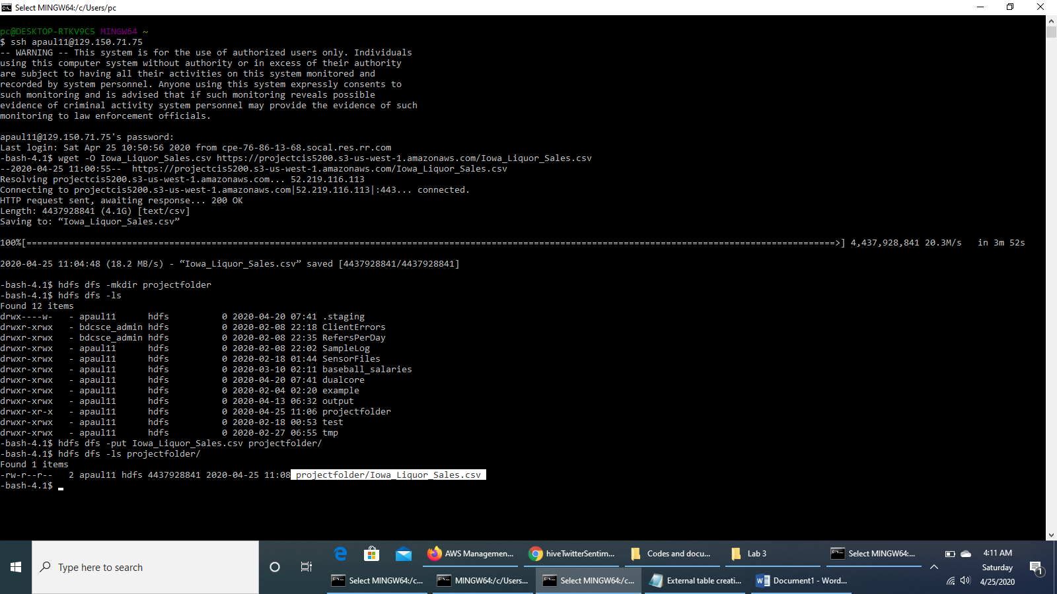

**Run the HDFS command to make beeline command work, open beeline CLI and copy and paste “!connect …” command**

hdfs dfs -chmod -R o+w .

beeline

!connect jdbc:hive2://bigdai1-bdcsce-1:2181,bigdai1-bdcsce-2:2181,bigdai1-bdcsce-3:2181/;serviceDiscoveryMode=zooKeeper;zooKeeperNamespace=hiveserver2?tez.queue.name=interactive bdcsce_admin

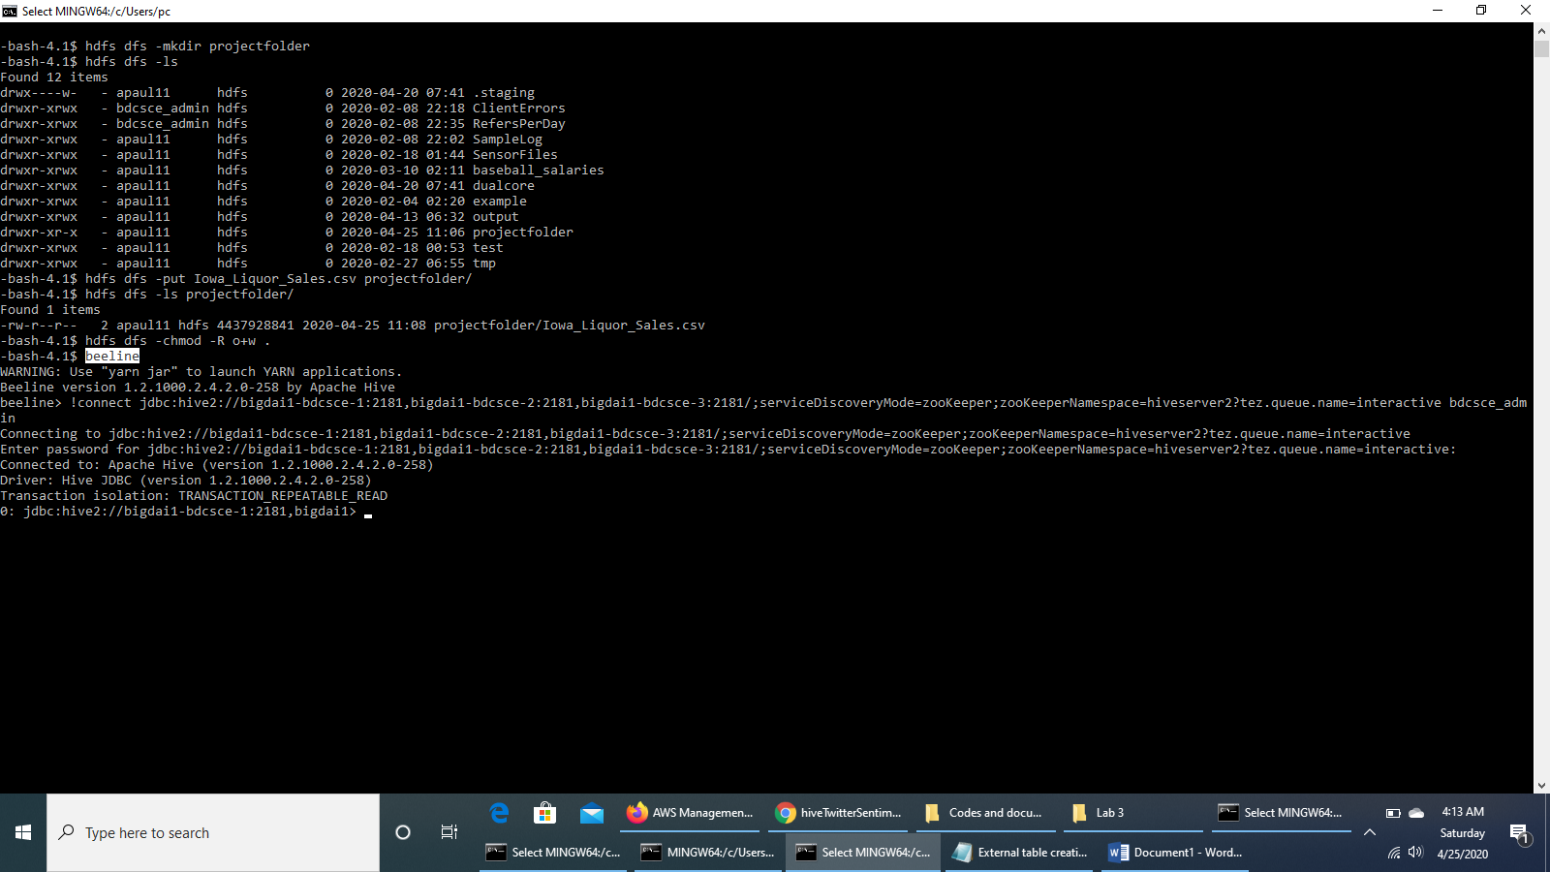

**See the list of databases already created and use our database to run further queries**

show databases;

use apaul11; [Alternatively: use tkhan9;]

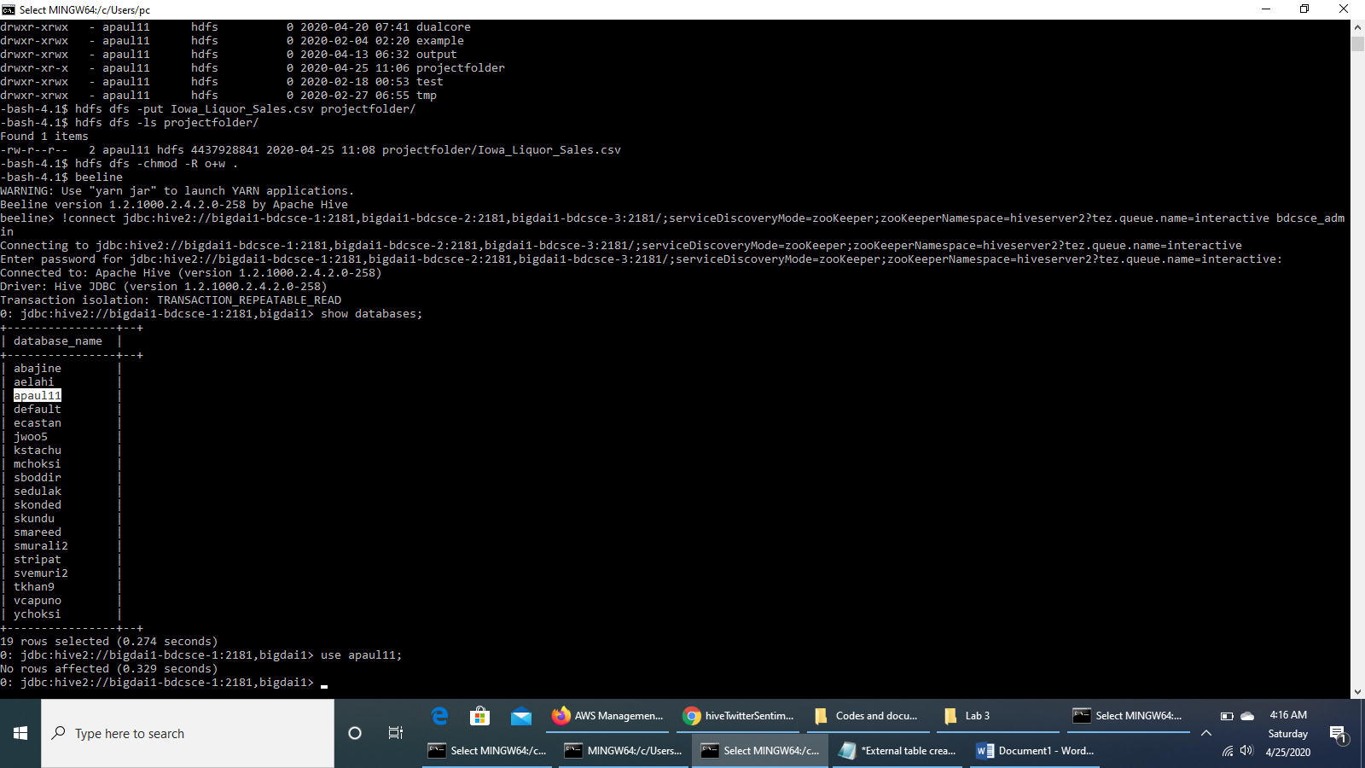

**Run the HiveQL code to create an external table named *iowaliquorsales***

DROP TABLE IF EXISTS iowaLiquorSales;

CREATE EXTERNAL TABLE IF NOT EXISTS IowaLiquorSales(Invoice_Item_Number string, Sale_Date

date, Store_Number string, Store_Name string, Address string,

City string, Zip_Code string, Store_Location string, County_Number

string, County string,

Category string, Category_Name string, Vendor_Number string, Vendor_Name

string, Item_Number string,

Item_Description string, Pack int, Bottle_Volume_ml int, State_Bottle_Cost

double, State_Bottle_Retail double, Bottles_Sold int, Sale_in_Dollars double,

Volume_Sold_in_Litres double, Volume_Sold_in_Gallons double )

ROW FORMAT DELIMITED FIELDS TERMINATED BY ','

STORED AS TEXTFILE LOCATION '/user/tkhan9/projectfolder/'

TBLPROPERTIES ('skip.header.line.count'='1');

**Check that the table *iowaliquorsales* has been created**

show tables;

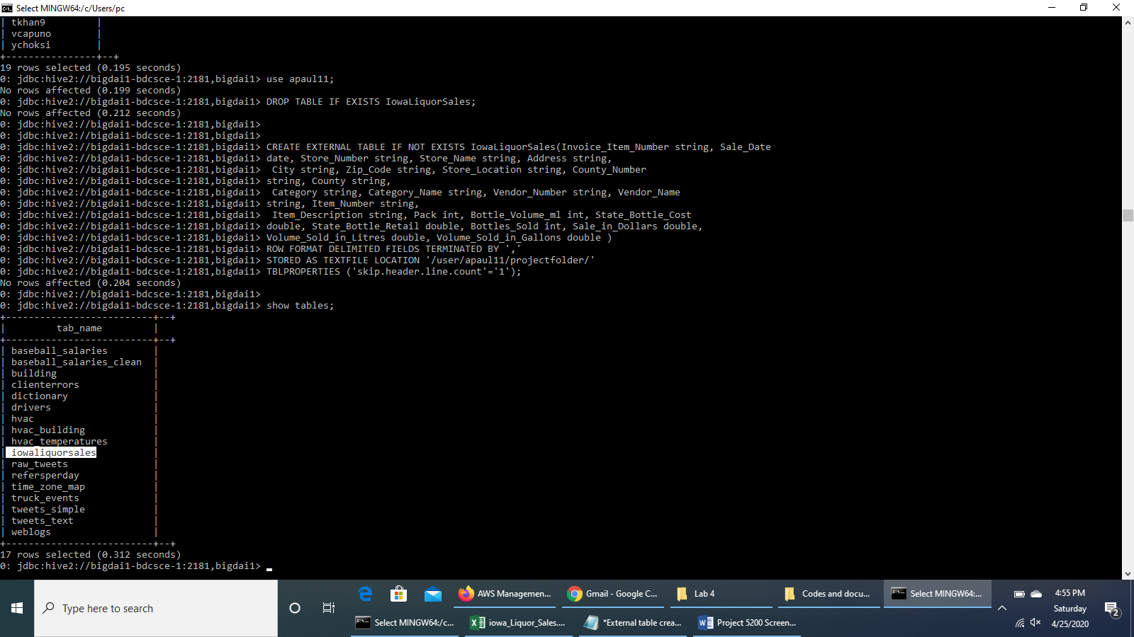

**Check the detailed structure of the table *iowaliquorsales***

describe iowaliquorsales;

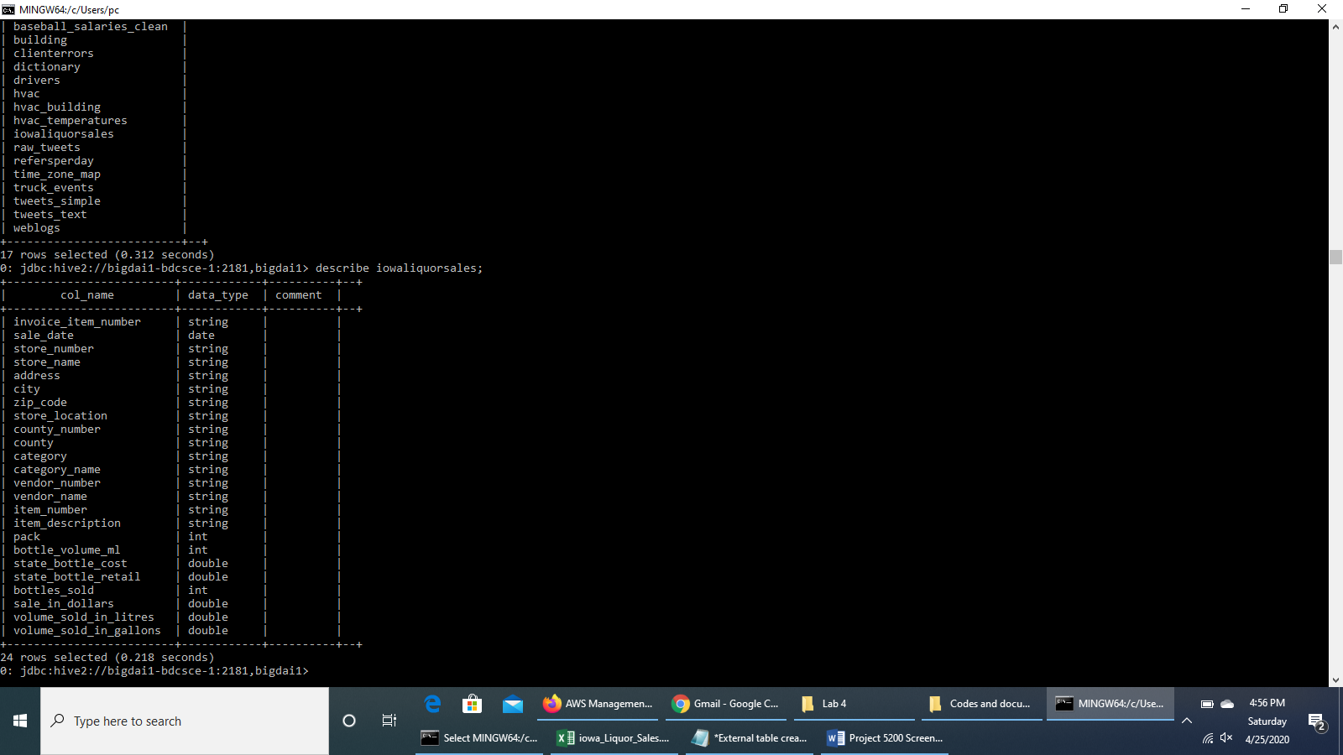

**Check if the table *iowaliquorsales* has the value once it is well created**

SELECT * FROM iowaliquorsales LIMIT 2

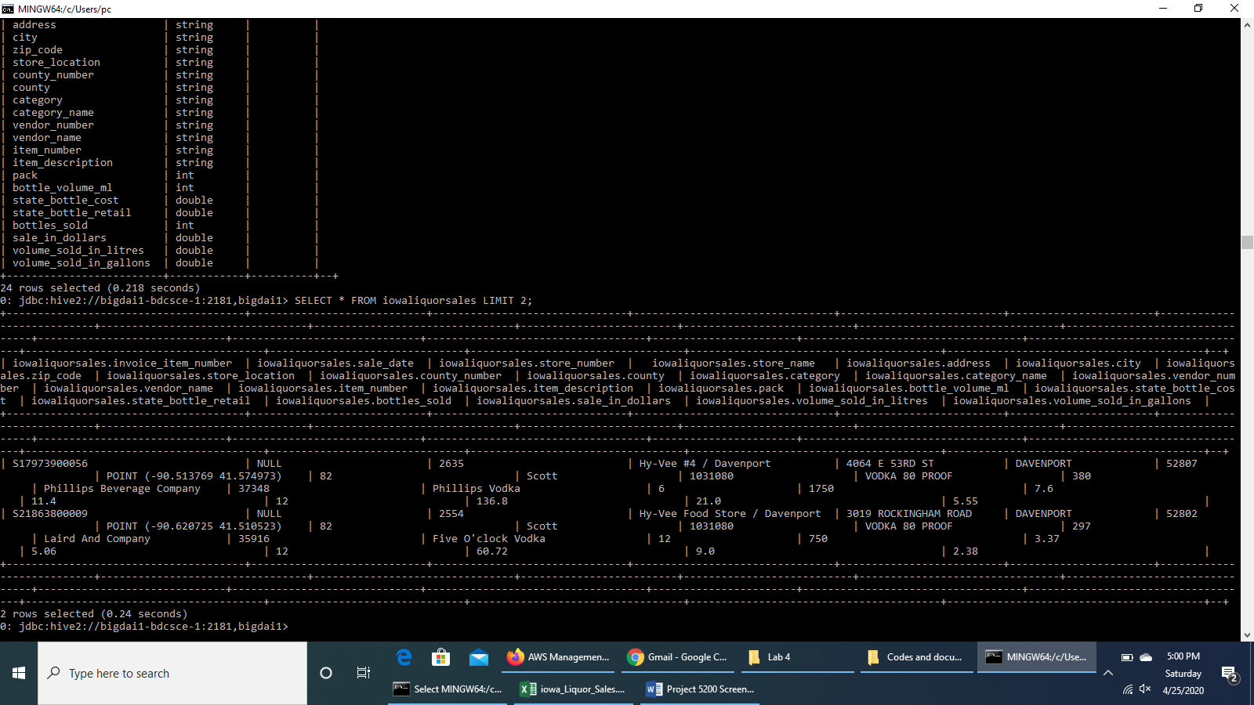

**Alter columns & Change Date Format**

ALTER TABLE iowaliquorsales CHANGE sale_date sale_date timestamp;

ALTER TABLE iowaliquorsales CHANGE sale_in_dollars sale_in_dollars bigint;

ALTER TABLE iowaliquorsales CHANGE volume_sold_in_litres volume_sold_in_litres bigint;

ALTER TABLE iowaliquorsales CHANGE volume_sold_in_gallons volume_sold_in_gallons bigint;

ALTER TABLE iowaliquorsales SET SERDEPROPERTIES ("timestamp.formats"="MM/dd/yyyy");

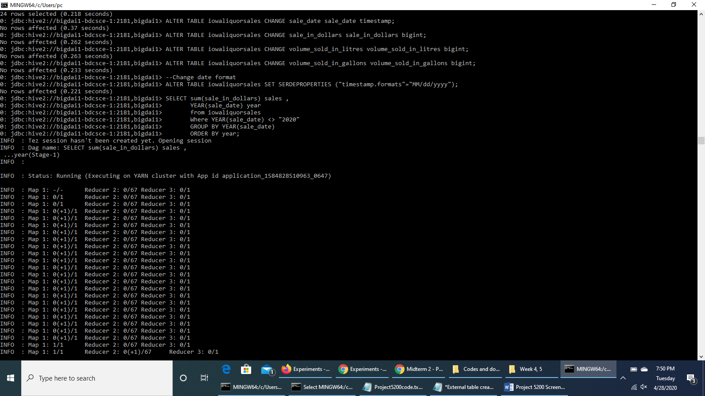

**Run Hive queries to analyze Sales trend of liquor over the years**

SELECT sum(sale_in_dollars) sales ,

YEAR(sale_date) year

from iowaliquorsales

Where YEAR(sale_date) <> "2020"

GROUP BY YEAR(sale_date)

ORDER BY year;



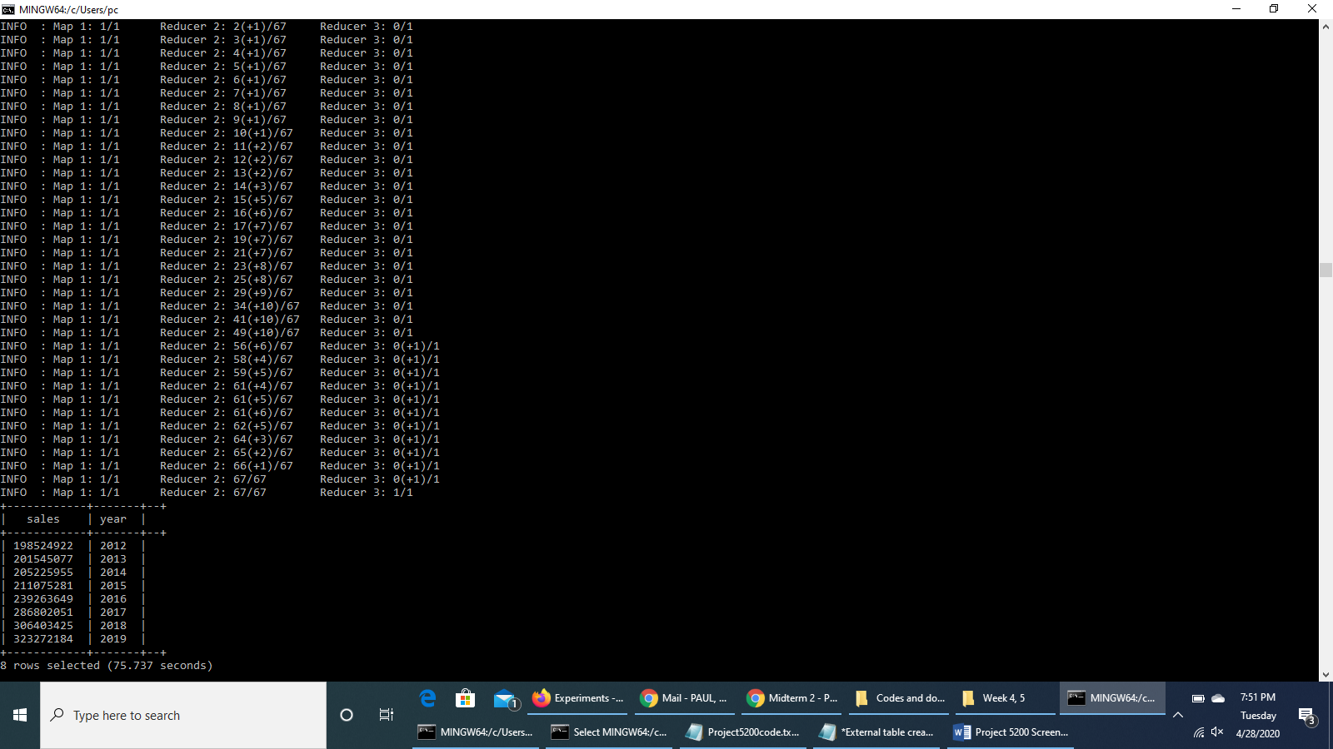

**Run Hive queries to find out the Top 10 counties in terms of sale amount in Dollars**

SELECT sum(sale_in_dollars) sales ,

upper(County) County

from iowaliquorsales

GROUP BY upper(county)

ORDER BY sales DESC limit 10;

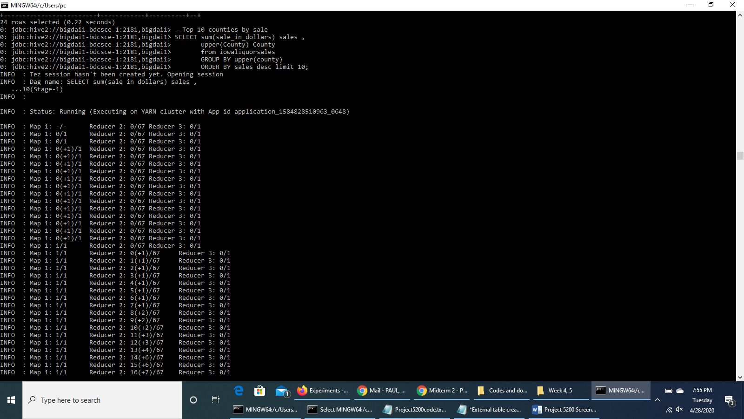

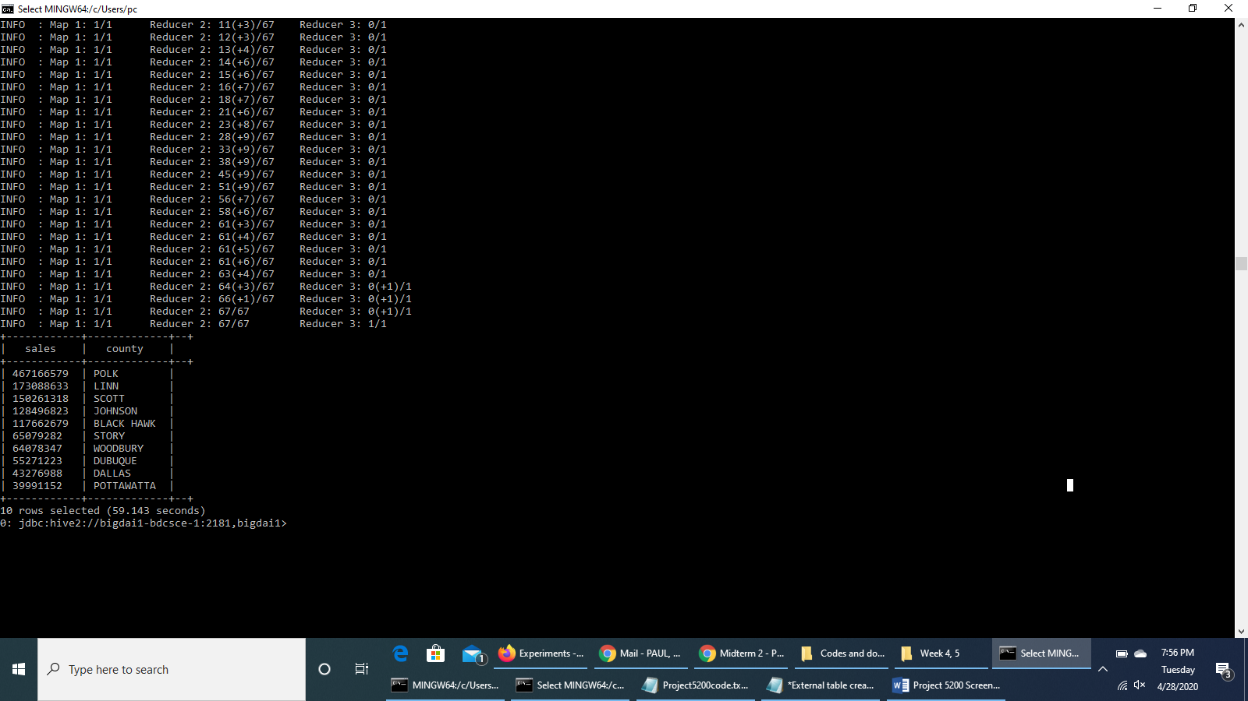

**Run Hive queries to find out the Top 5 categories of liquors sold with highest volume in Litres**

SELECT SUM(Volume_Sold_in_Litres) volume,

SUM(sale_in_dollars) sales ,

upper(Category_Name) CategoryName

FROM iowaliquorsales

GROUP BY upper(Category_Name)

ORDER BY volume DESC limit 5;

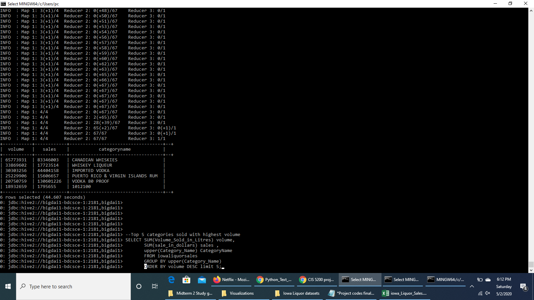

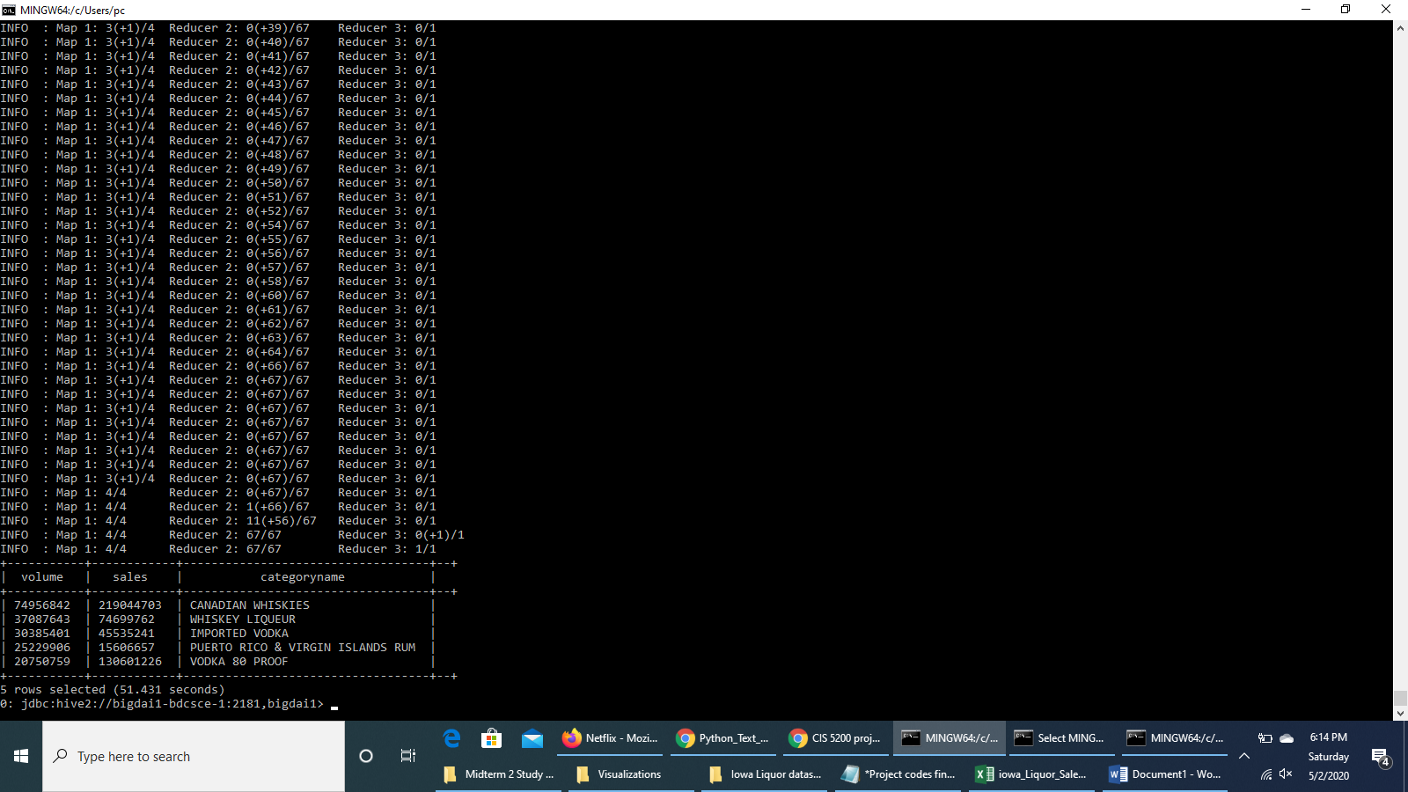

**Run Hive queries to find out the Top 10 cities with highest sales in Dollars**

SELECT sum(sale_in_dollars) sales ,

upper(City) City

FROM iowaliquorsales

GROUP BY upper(City)

ORDER BY sales DESC LIMIT 10;

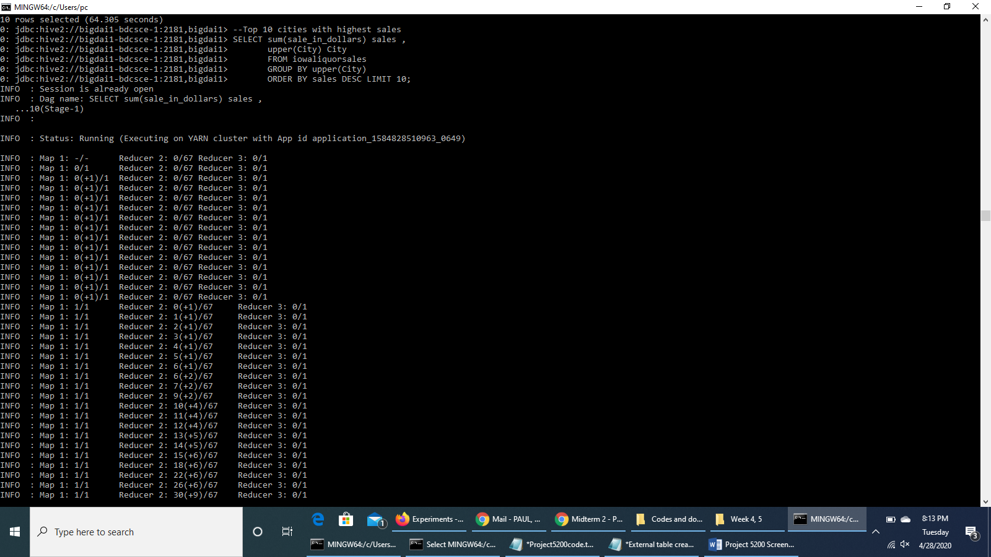

**Run Hive queries to find out Sale of Canadian Whiskies across counties for the year 2019**

SELECT Invoice_Item_Number,

sale_in_dollars sales,

County,

sale_date

FROM iowaliquorsales

where upper(category_name) = 'CANADIAN WHISKIES'

And YEAR(sale_date) = "2019";

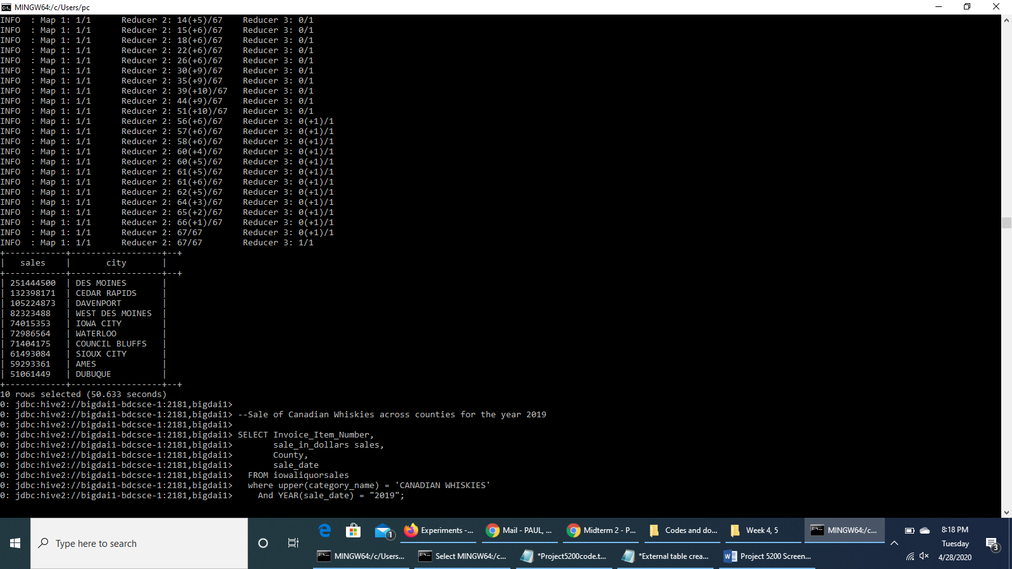

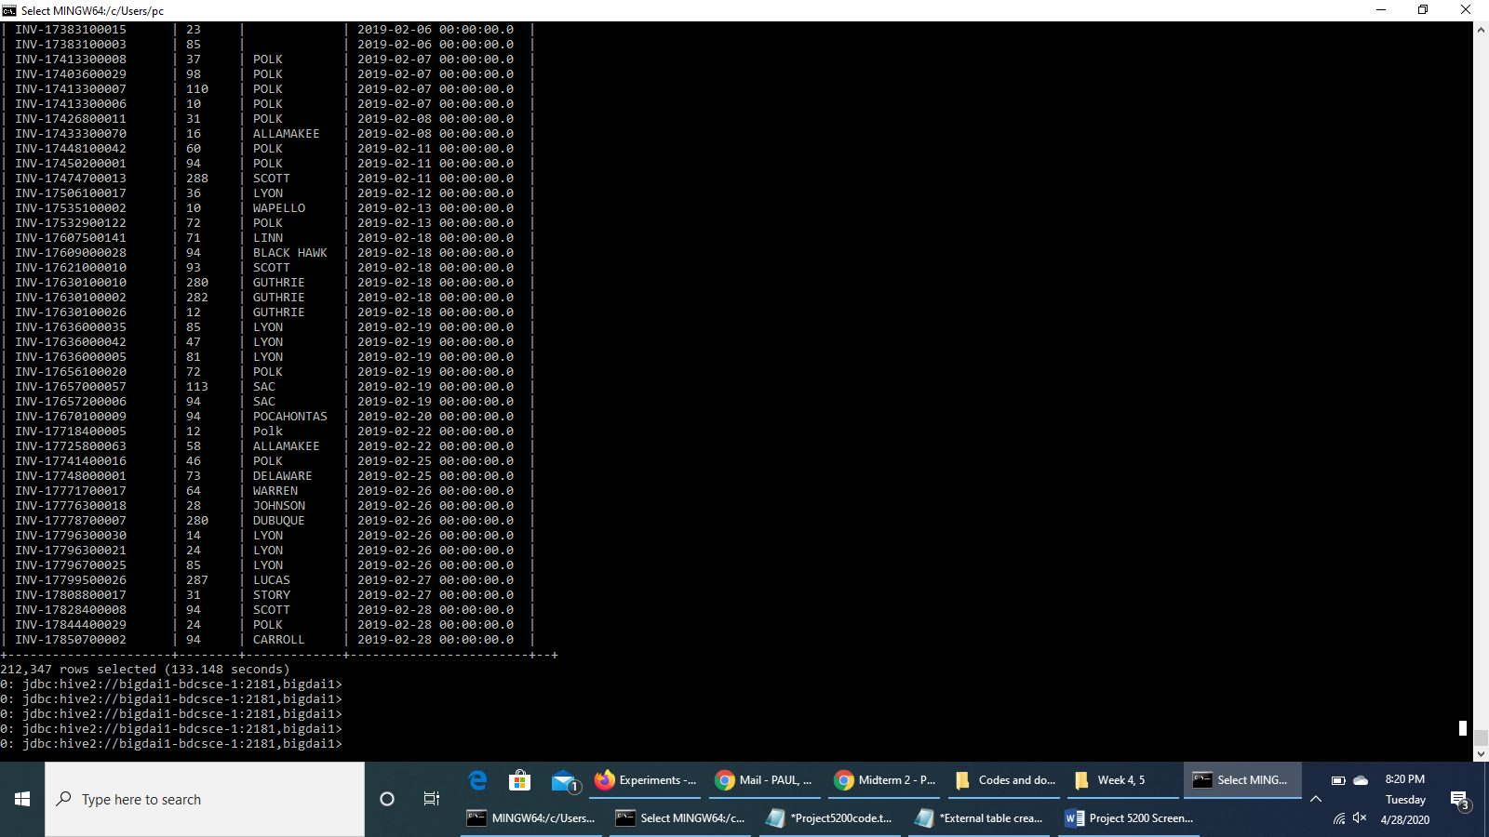

**We run HiveQL code to create a table *SaleCanadianWhiskies* to store the data of the sale of Canadian Whiskies across counties for the year 2019 for extraction**

DROP TABLE IF EXISTS SaleCanadianWhiskies;

CREATE TABLE IF NOT EXISTS SaleCanadianWhiskies

ROW FORMAT DELIMITED FIELDS TERMINATED BY ','

STORED AS TEXTFILE LOCATION '/user/tkhan9/projectfolder/SaleCanadianWhiskies/'

AS

SELECT Invoice_Item_Number,

sale_in_dollars sales,

County,

sale_date

FROM iowaliquorsales

where upper(category_name) = 'CANADIAN WHISKIES'

And YEAR(sale_date) = "2019";

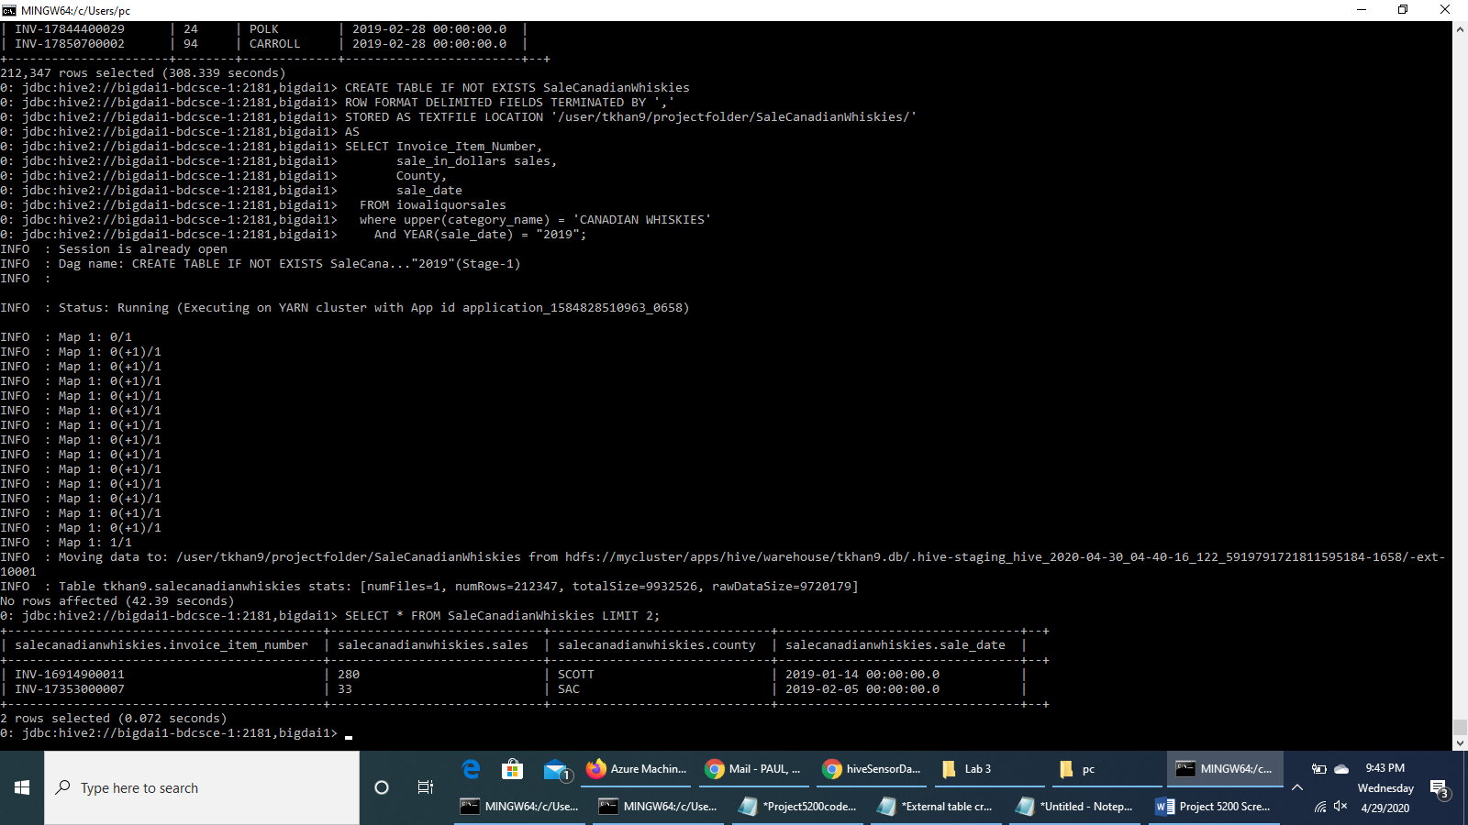

**Press CTRL+Z to exit Beeline**

**Check HDFS path of the output file 000000_0**

hdfs dfs -ls projectfolder/SaleCanadianWhiskies

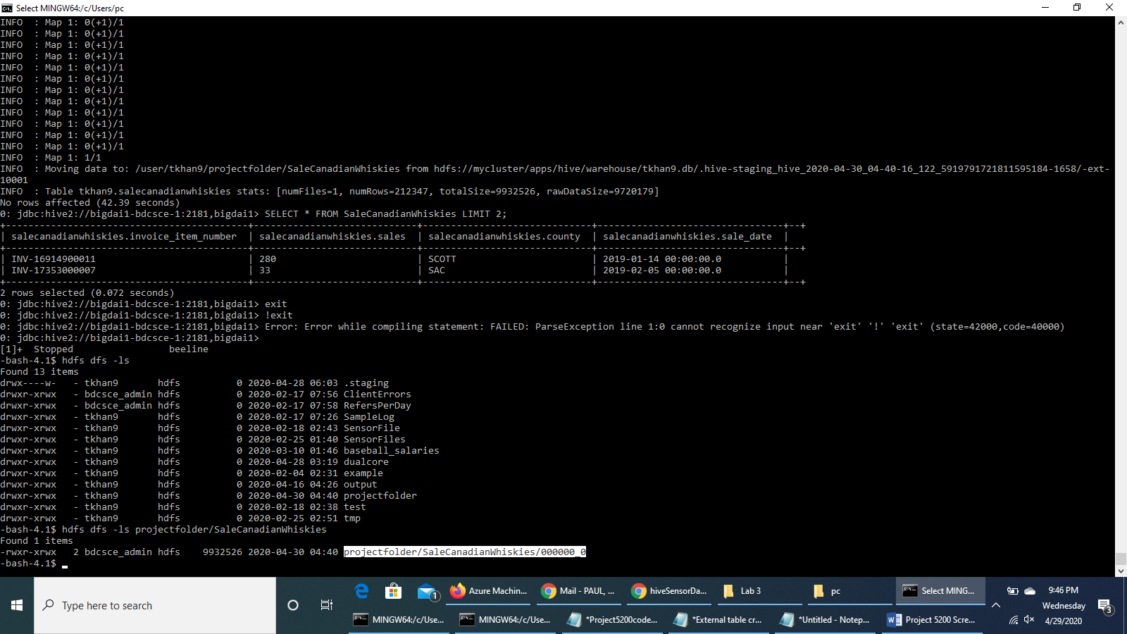

**To download the output file to the local file systems**

hdfs dfs -get projectfolder/SaleCanadianWhiskies/000000_0

ls -al

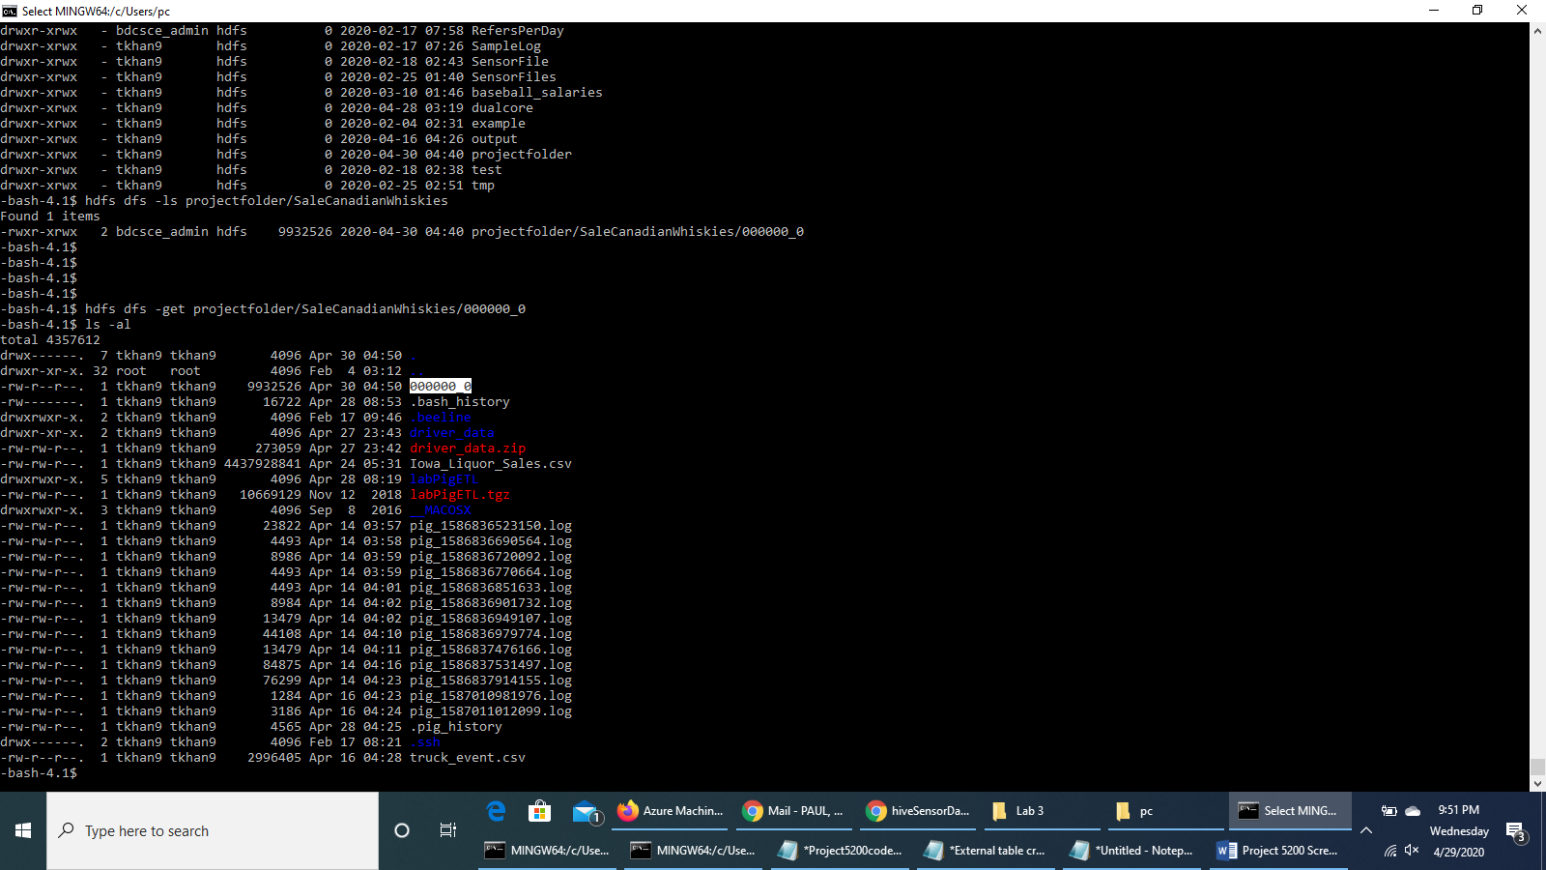

**Open another terminal with git bash, minty, or putty in order to read/import the output file using your lab computer (or your PC/Laptop) - you have to download the file to your computer (or your PC/Laptop).**

scp tkhan9@129.150.71.75:/home/tkhan9/000000_0 000000_0.csv

**Screenshot of the extracted csv file:**

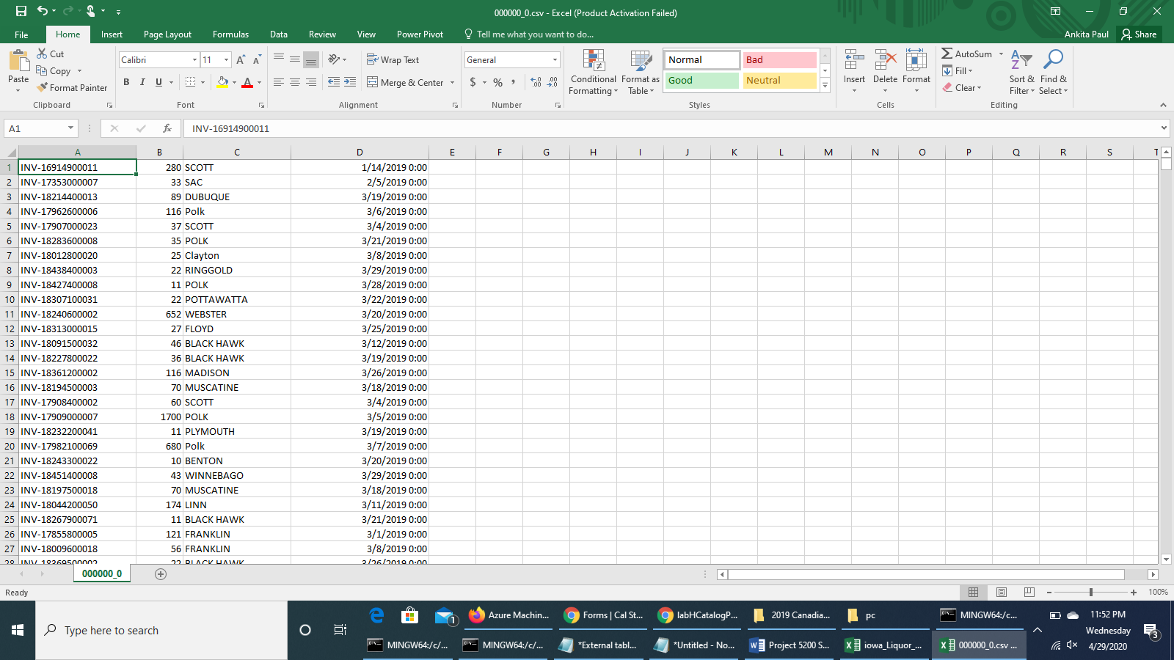

**Screenshot of the Temporal analysis visualization of the Sale of Canadian Whiskies in 2019 on *MS Excel Pivot Chart***

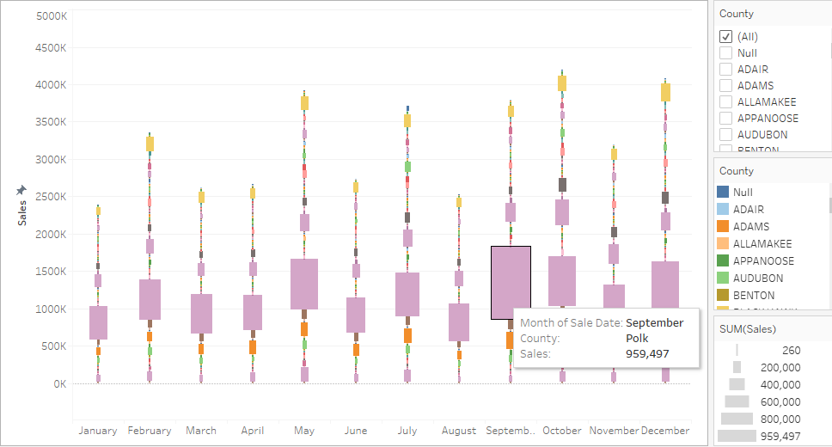

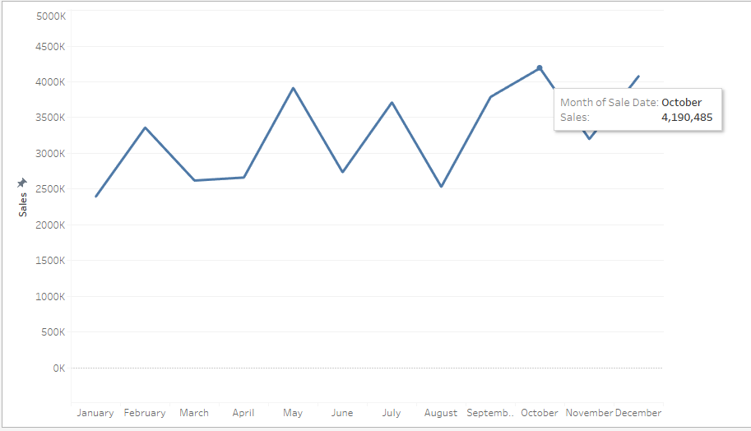

**Tempo-spatial analysis - Sale of Canadian Whiskies across counties**

We used a cleaned dataset “Cleaned_Location_data.csv” by splitting the “Store Location” column from the orginal dataset into two separate columns of “Longitude” and “Latitude”.

**Before proceeding with the next part of analysis, we will remove the previous output data file.**

rm 000000_0

**Download the new data input file from Amazon S3**

wget –O Cleaned_location_data.csv <https://projectcis5200.s3-us-west-1.amazonaws.com/Cleaned_location_data.csv>

**Put the CSV input file in *tempo_spatial_data* directory in HDFS**

1. hdfs dfs -mkdir projectfolder/tempo_spatial_data

2. hdfs dfs -put Cleaned_location_data.csv projectfolder/tempo_spatial_data/

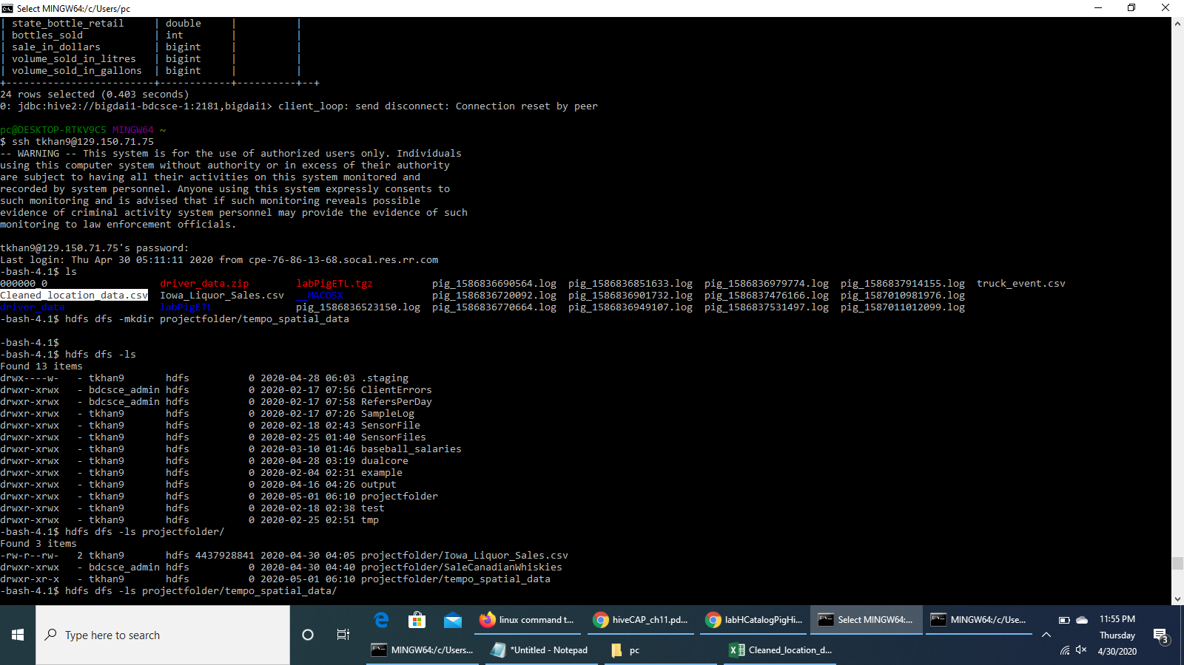

**Run the earlier commands to connect to Beeline and use the database tkhan9 by running the Hive command in Beeline CLI.**

**Create an external table *sale_location_data***

DROP TABLE IF EXISTS sale_location_data;

CREATE EXTERNAL TABLE IF NOT EXISTS sale_location_data(Invoice_or_Item_Number string, Date_of_sale

date, StoreNumber string, StoreName string,

City string, Zip_Code string, Longitude double, Latitude double, County string,

Category_Name string, Sale_Amount double,

Volume_Sold_litres double)

ROW FORMAT DELIMITED FIELDS TERMINATED BY ','

STORED AS TEXTFILE LOCATION '/user/tkhan9/projectfolder/tempo_spatial_data/'

TBLPROPERTIES ('skip.header.line.count'='1');

**Check that the table *sale_location_data* has been created**

show tables;

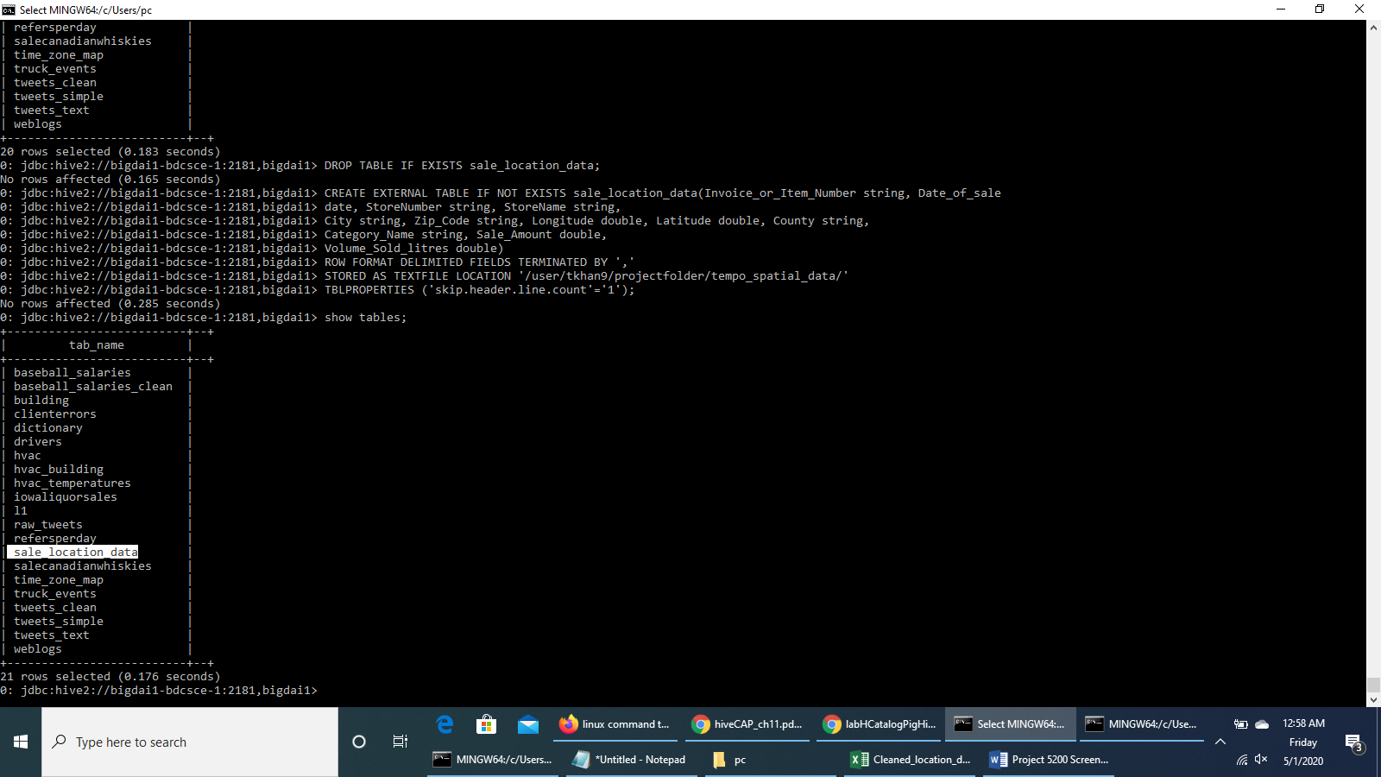

**Alter columns & Change Date Format**

ALTER TABLE sale_location_data CHANGE Date_of_sale Date_of_sale timestamp;

ALTER TABLE sale_location_data CHANGE Sale_Amount Sale_Amount bigint;

ALTER TABLE sale_location_data CHANGE Volume_Sold_litres Volume_Sold_litres bigint;

ALTER TABLE sale_location_data SET SERDEPROPERTIES ("timestamp.formats"="MM/dd/yyyy");

DESCRIBE sale_location_data;

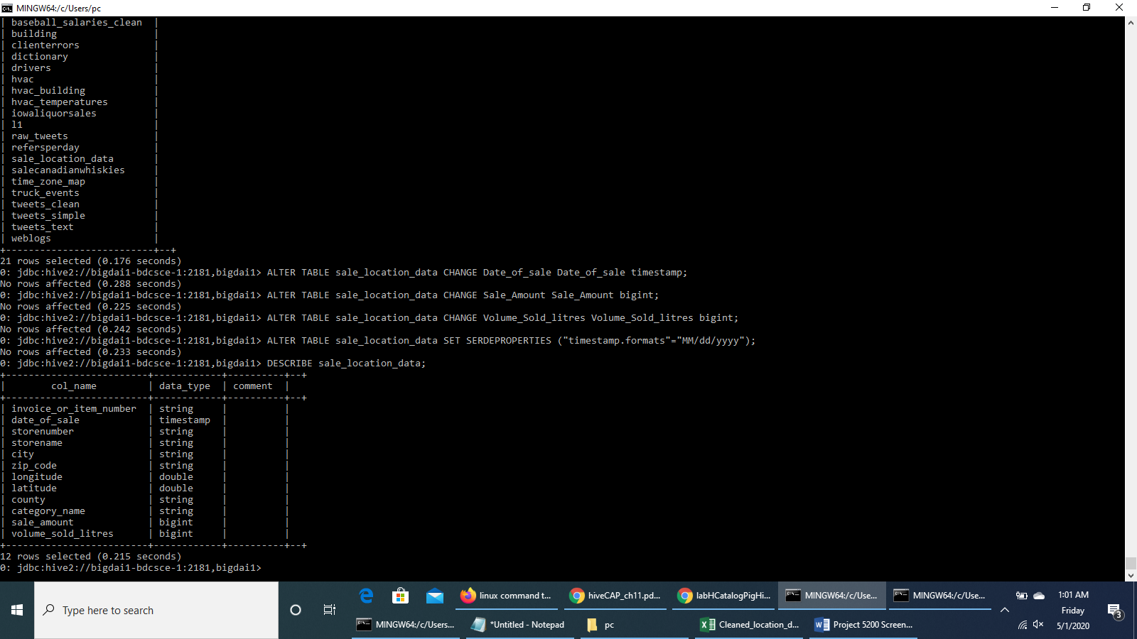

**Check if the table *sale_location_data* has the value once it is well created**

SELECT * FROM sale_location_data LIMIT 2;

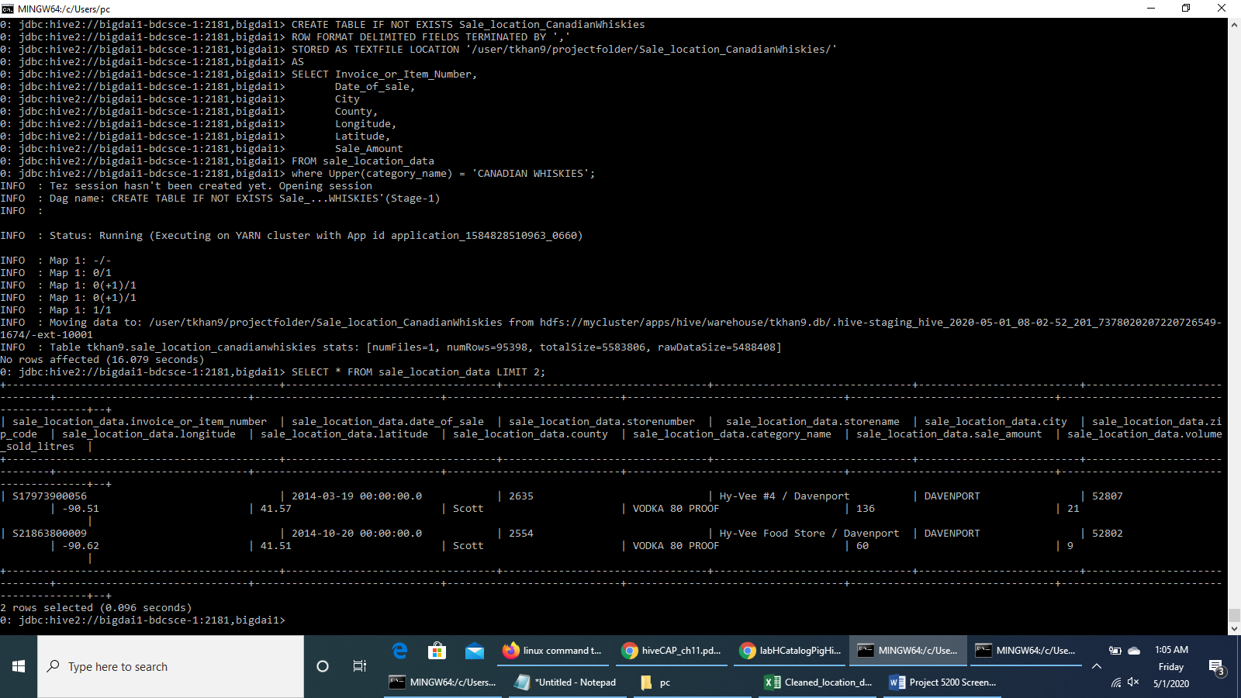

**We run HiveQL code to create a table *Sale_location_CanadianWhiskies* to store the data of the sale of Canadian Whiskies across counties over the years.**

DROP TABLE IF EXISTS Sale_location_CanadianWhiskies;

CREATE TABLE IF NOT EXISTS Sale_location_CanadianWhiskies

ROW FORMAT DELIMITED FIELDS TERMINATED BY ','

STORED AS TEXTFILE LOCATION '/user/tkhan9/projectfolder/Sale_location_CanadianWhiskies/'

AS

SELECT Invoice_or_Item_Number,

Date_of_sale,

County,

Longitude,

Latitude,

Sale_Amount

FROM sale_location_data

where Upper(category_name) = 'CANADIAN WHISKIES';

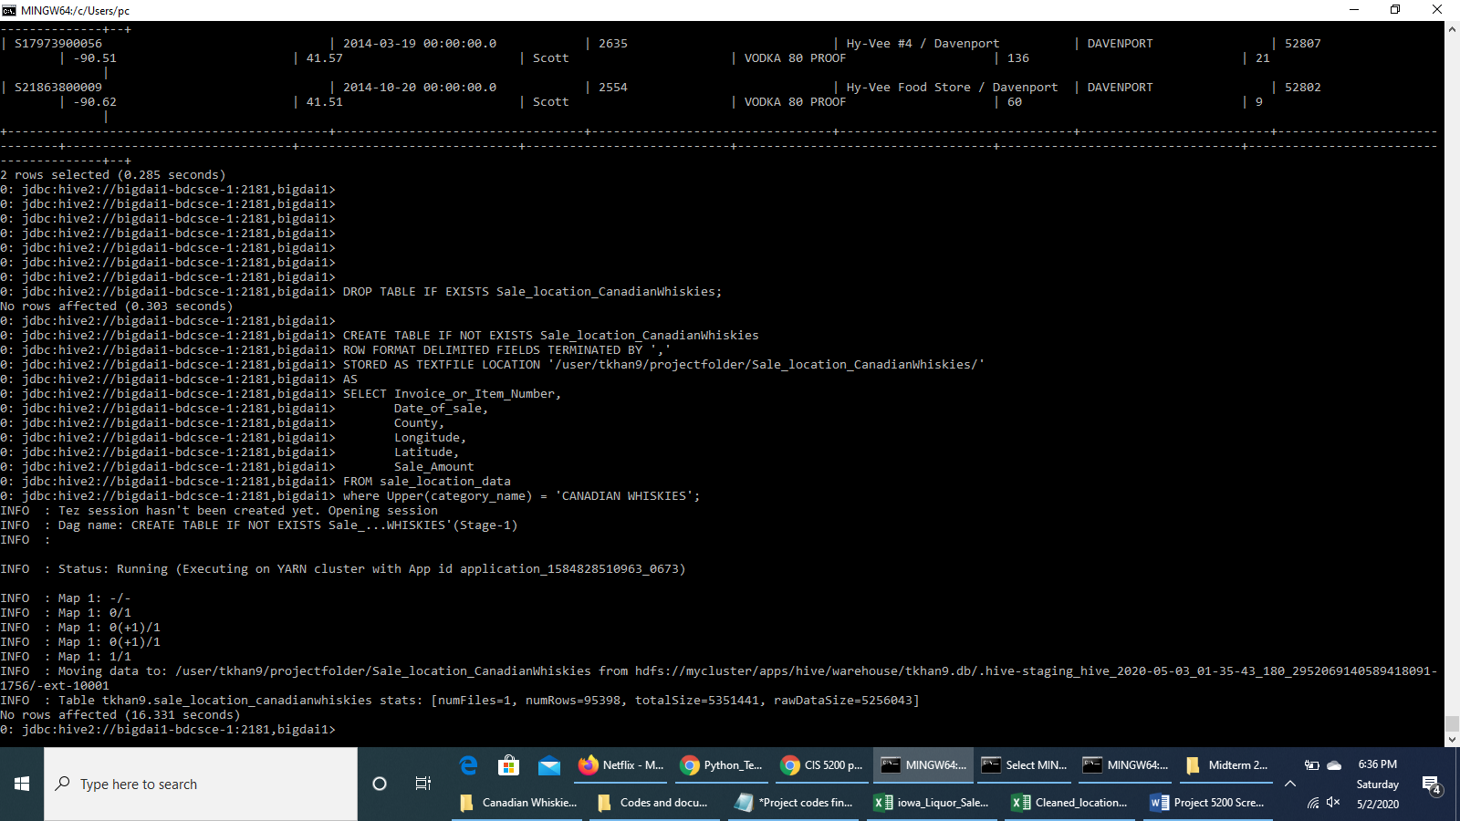

**We run a query to see the resulting data upto 2 rows**

SELECT * FROM Sale_location_CanadianWhiskies LIMIT 2;

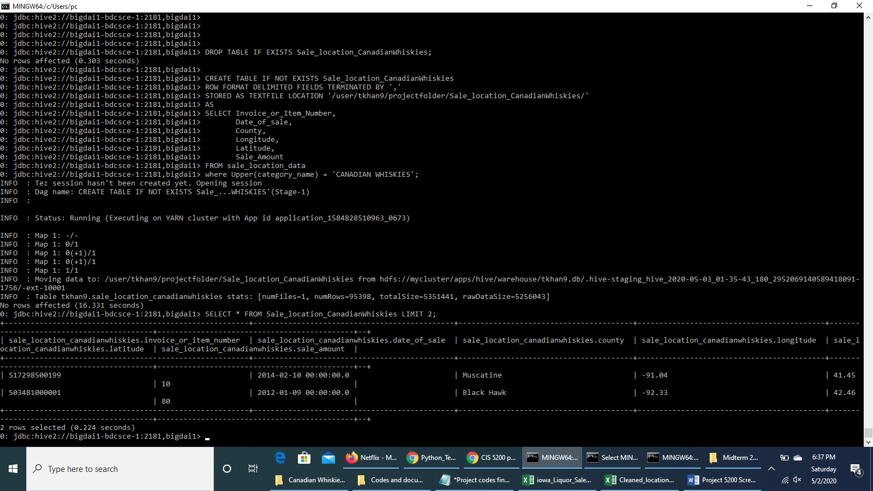

**Press CTRL+Z to exit Beeline**

**Check HDFS path of the new output file 000000_0**

hdfs dfs -ls projectfolder/Sale_Location_CanadianWhiskies/

**To download the output file to the local file systems**

hdfs dfs -get projectfolder/Sale_location_CanadianWhiskies/000000_0

ls -al

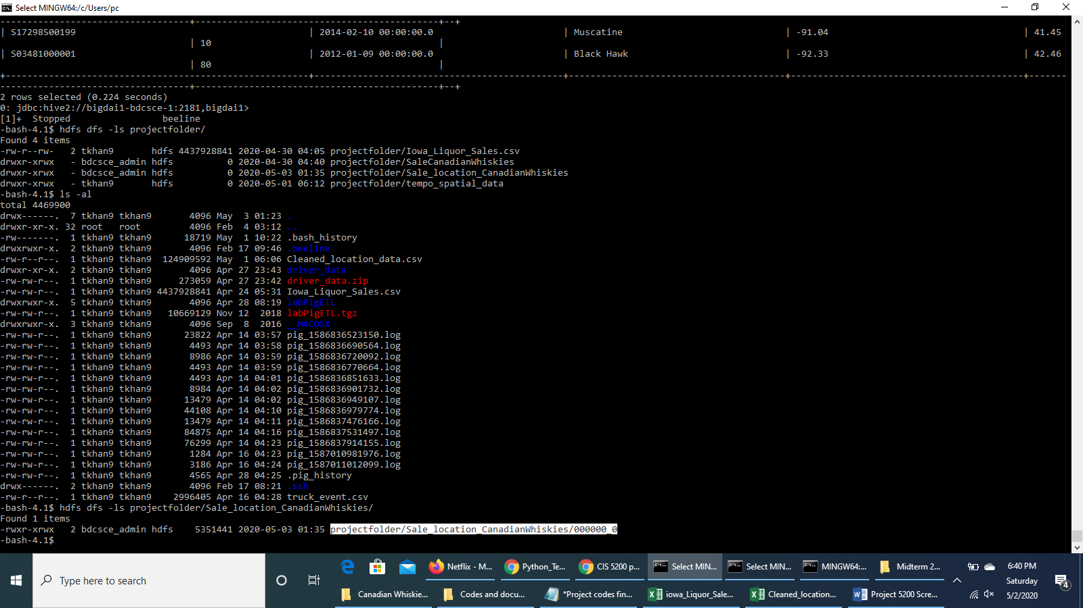

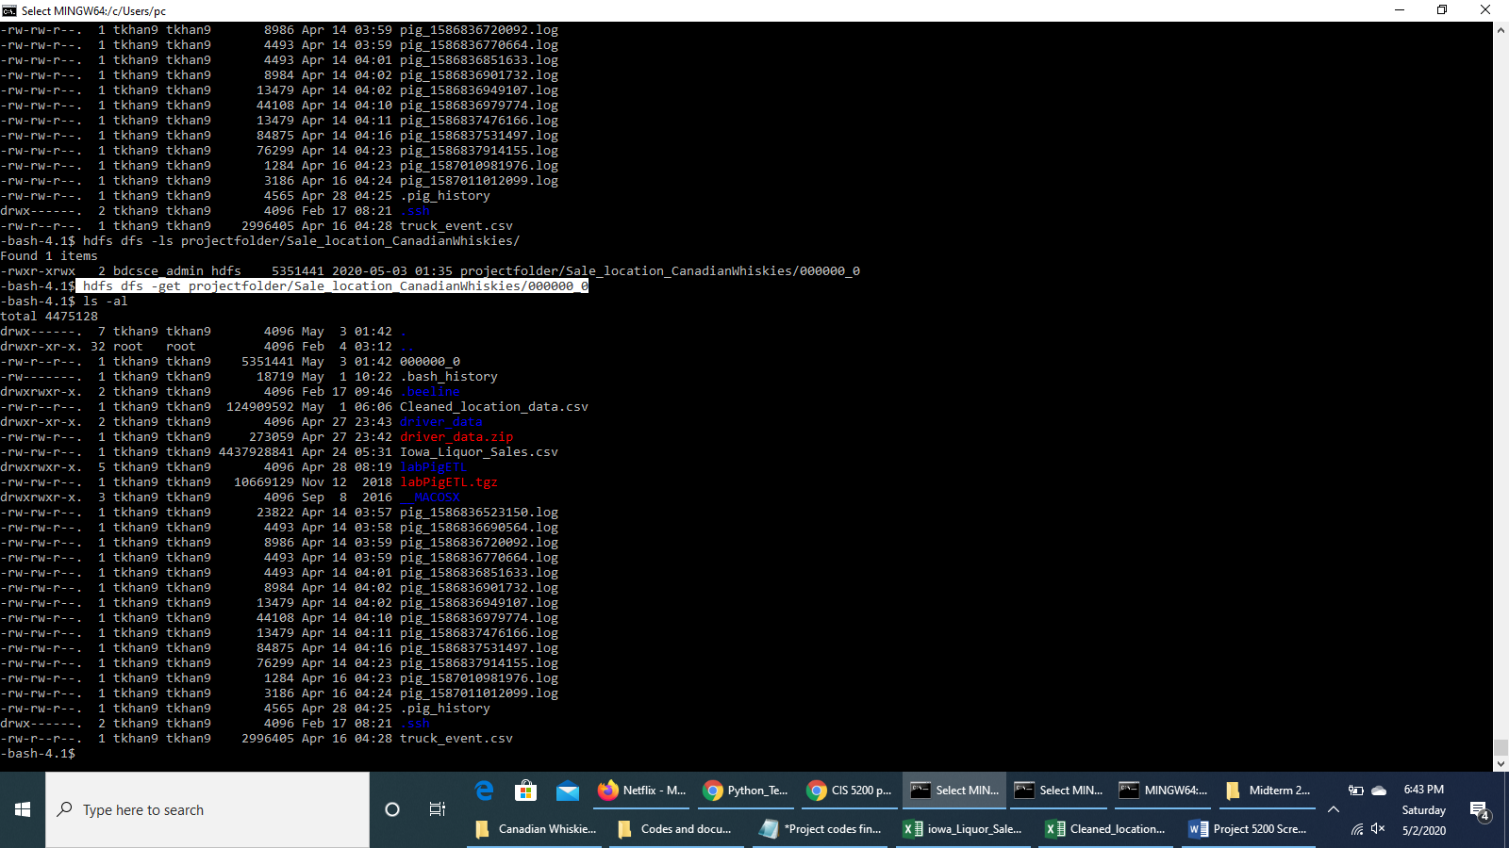

**Open another terminal with git bash, minty, or putty in order to read/import the output file using your lab computer (or your PC/Laptop) - you have to download the file to your computer (or your PC/Laptop).**

scp [tkhan9@129.150.71.75:/home/tkhan9/000000_0 000000_0.csv](mailto:tkhan9@129.150.71.75:/home/tkhan9/000000_0%20000000_0.csv)

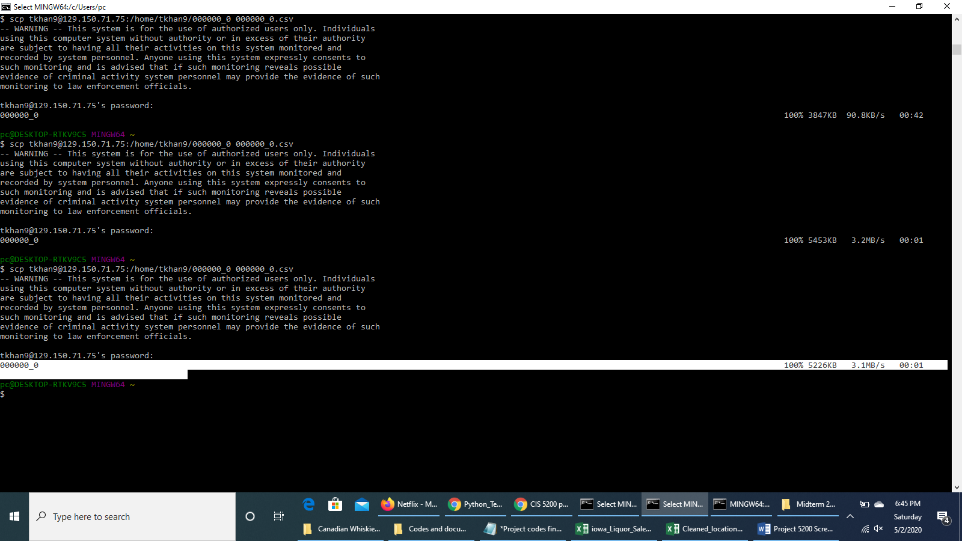

**Visualization on Excel 3D Map**

We opened the csv output file, inserted column headers as Invoice_or_Item_Number, Date_of_sale, Longitude, Latitude and Sale_Amount. We saved files in .xlsx format and renamed it to *Canadian_Whiskies_Sale_results*. We opened the 3D Map and selected the fields as follows:-

**Location :** Latitude

**Height :**  Sale_Amount (Sum)

**Category :** County

**Time :** Date_of_sale (Year)

**Filter > Add filter :** Invoice_or_Item_Number (All)

Selected ***Stacked Column*** type data visualization.

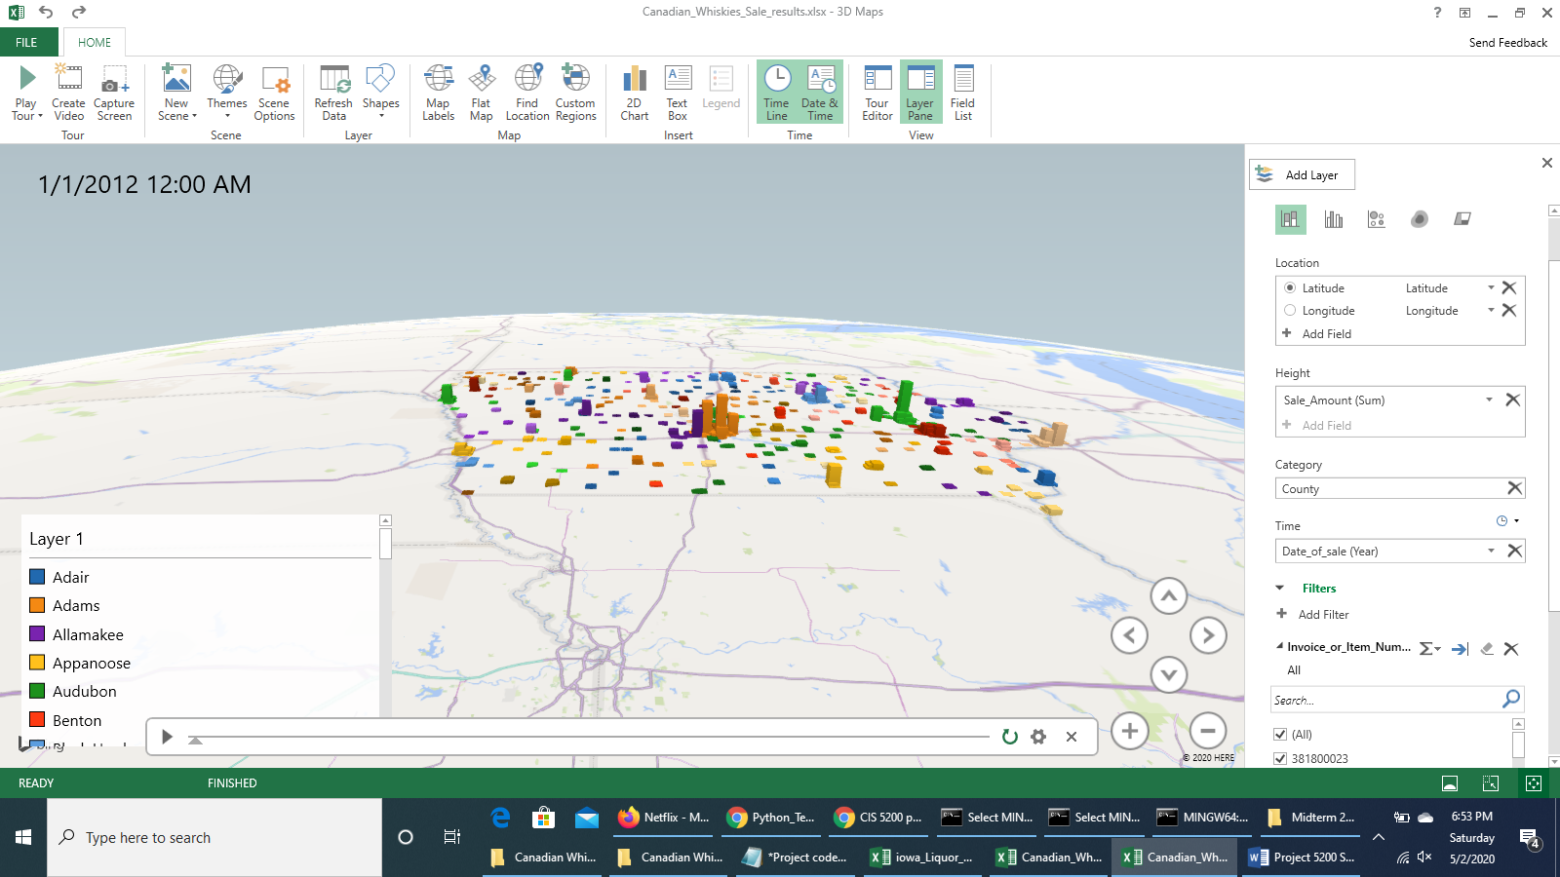

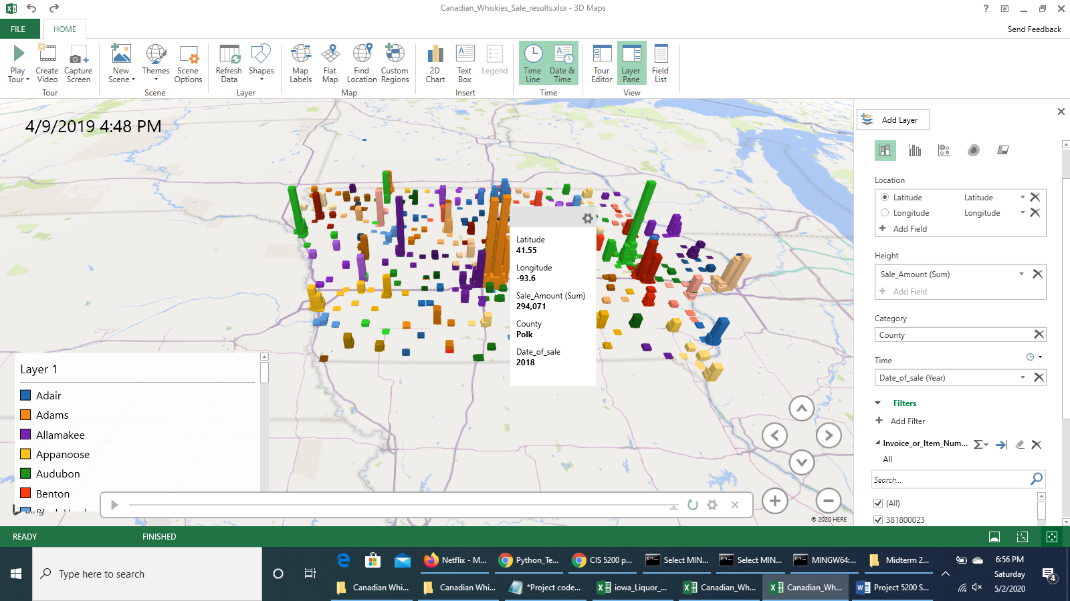

**Youtube Link to 3D Map Video capture:**

<https://youtu.be/nYV3qjIAUEI>

**Visualization on Power BI**

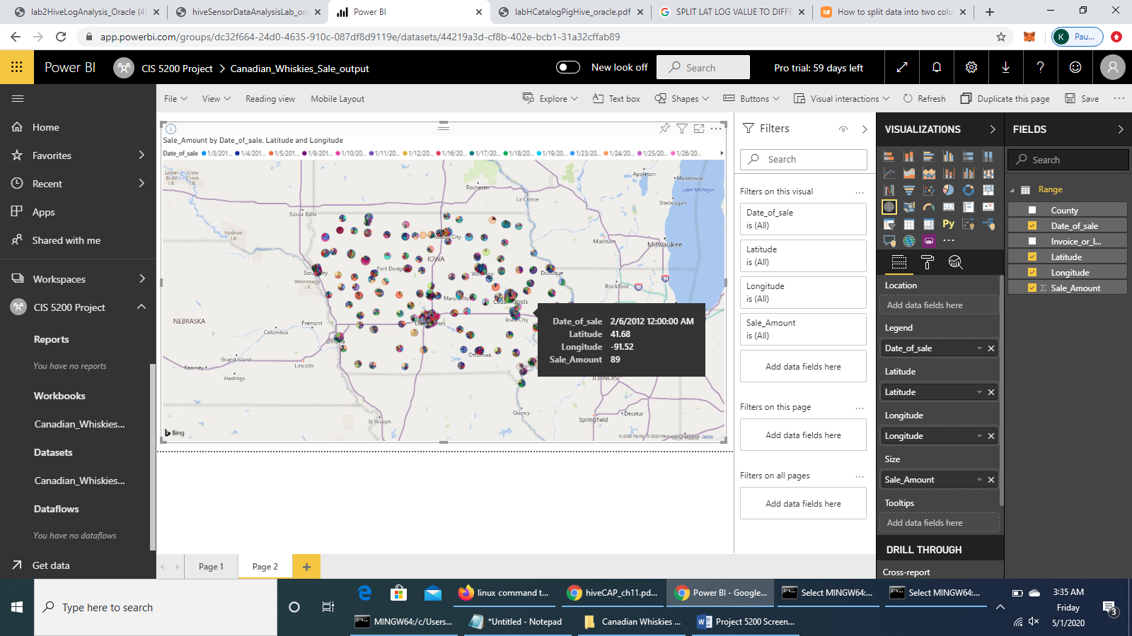

**Link of this report on Power BI**

<https://app.powerbi.com/groups/dc32f664-24d0-4635-910c-087df8d9119e/reports/bfa9f9a7-e08a-4518-9f9b-6e587f1f5a2e?ctid=ce8a2002-448f-4f58-82b1-d86f73e3afdd>